You can download dataset from url: <https://fossdroid.com/>

Download all apks in the following folder:

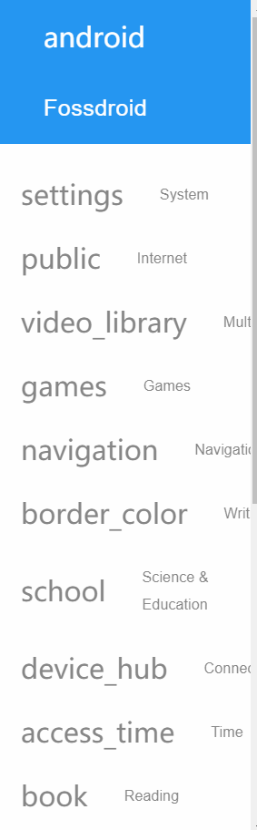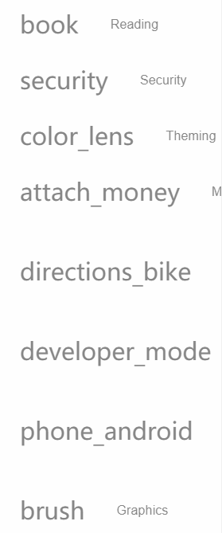

The other dataset url is <https://en.softonic.com/android> ,you can also download APK from this url link.